Dynamic View of the platform for Strategic Awareness Games

# Conduct a Game

## Participate in a Group Game

### Join a Group Game

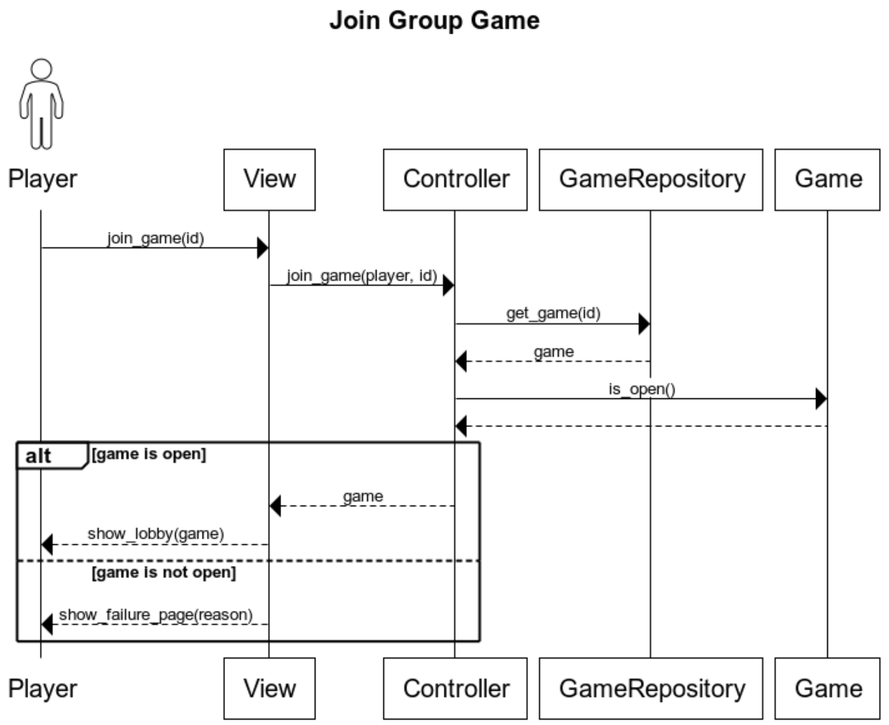

Figure 1: Join Group Game

### Play a Group Game

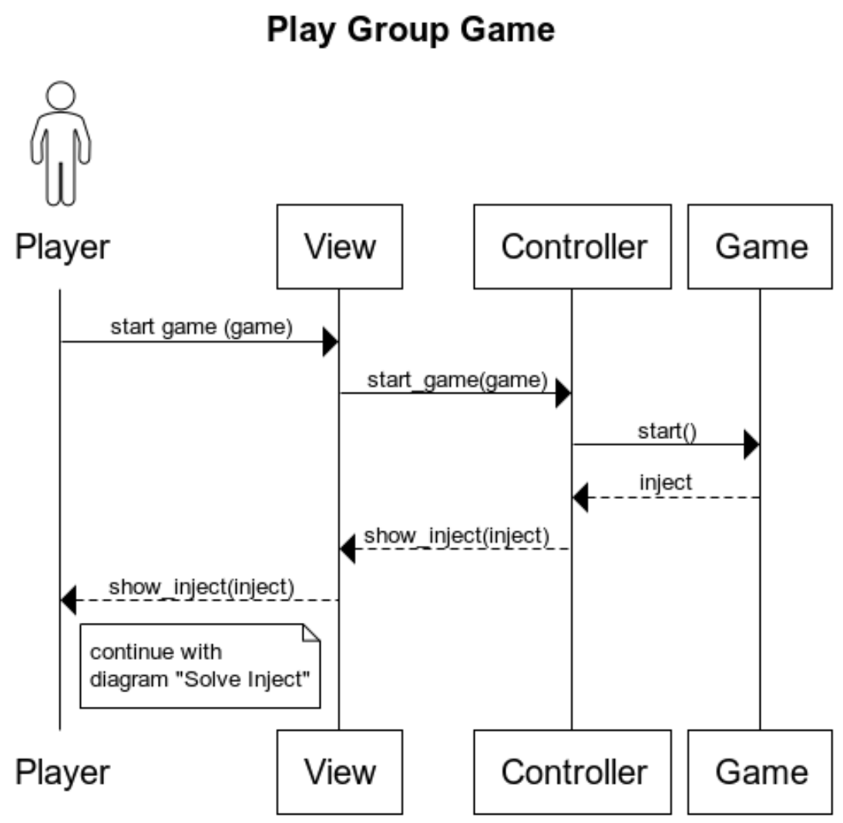

Figure 2: Participate in a Game

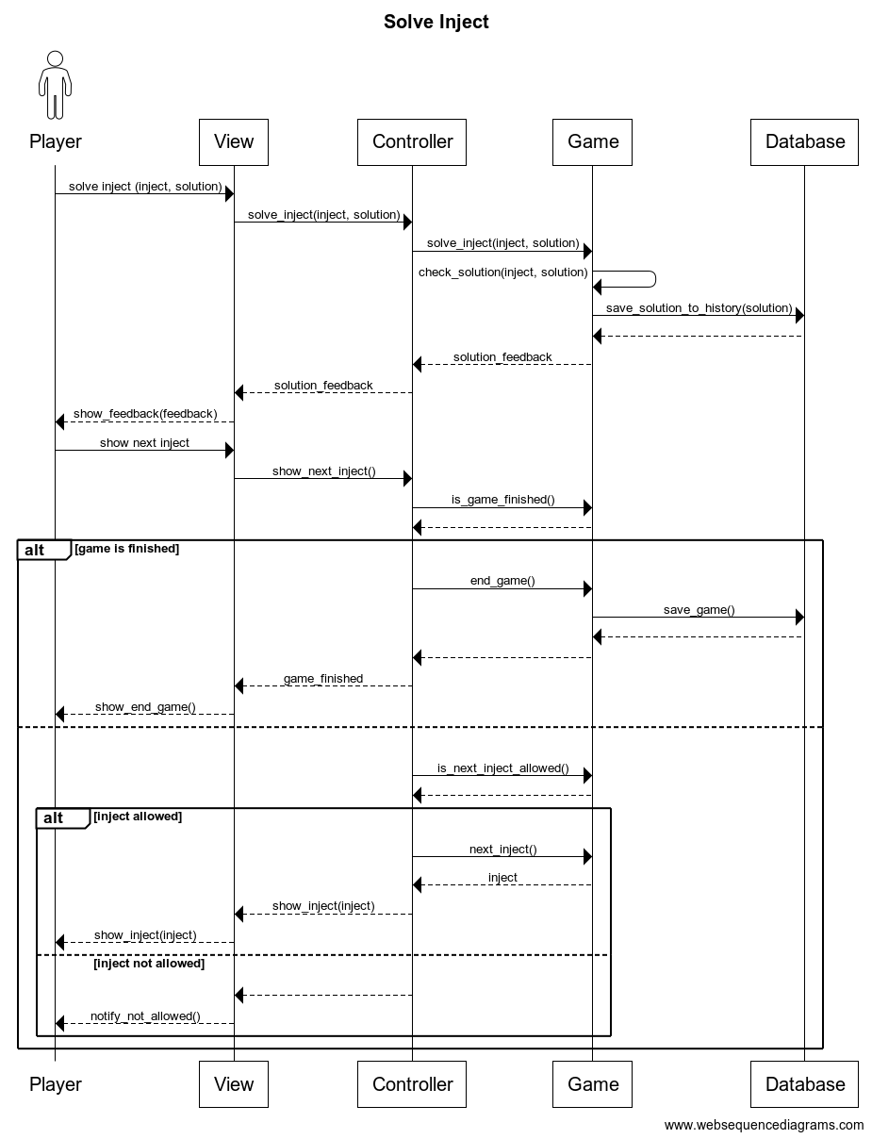

## Facilitate a Group Game

### Open Group Game

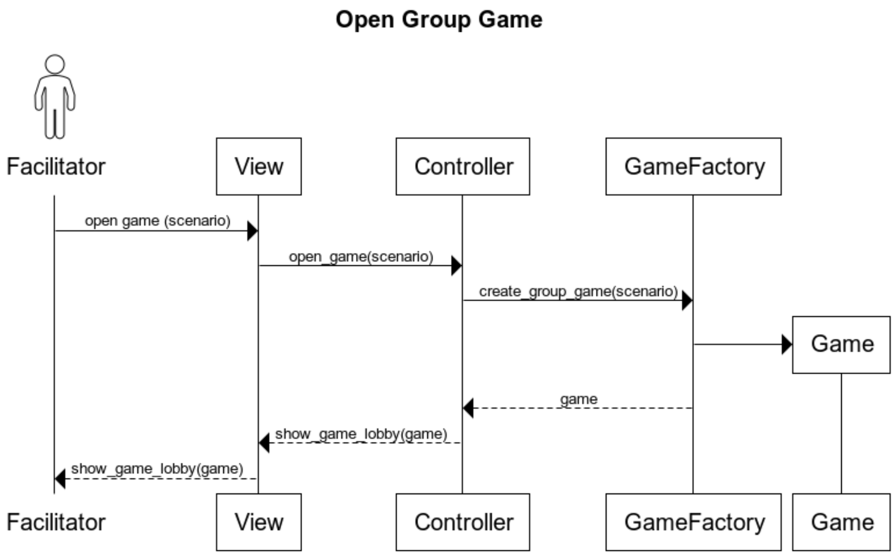

Figure 3: Open a Group Game

### Observe a Group Game

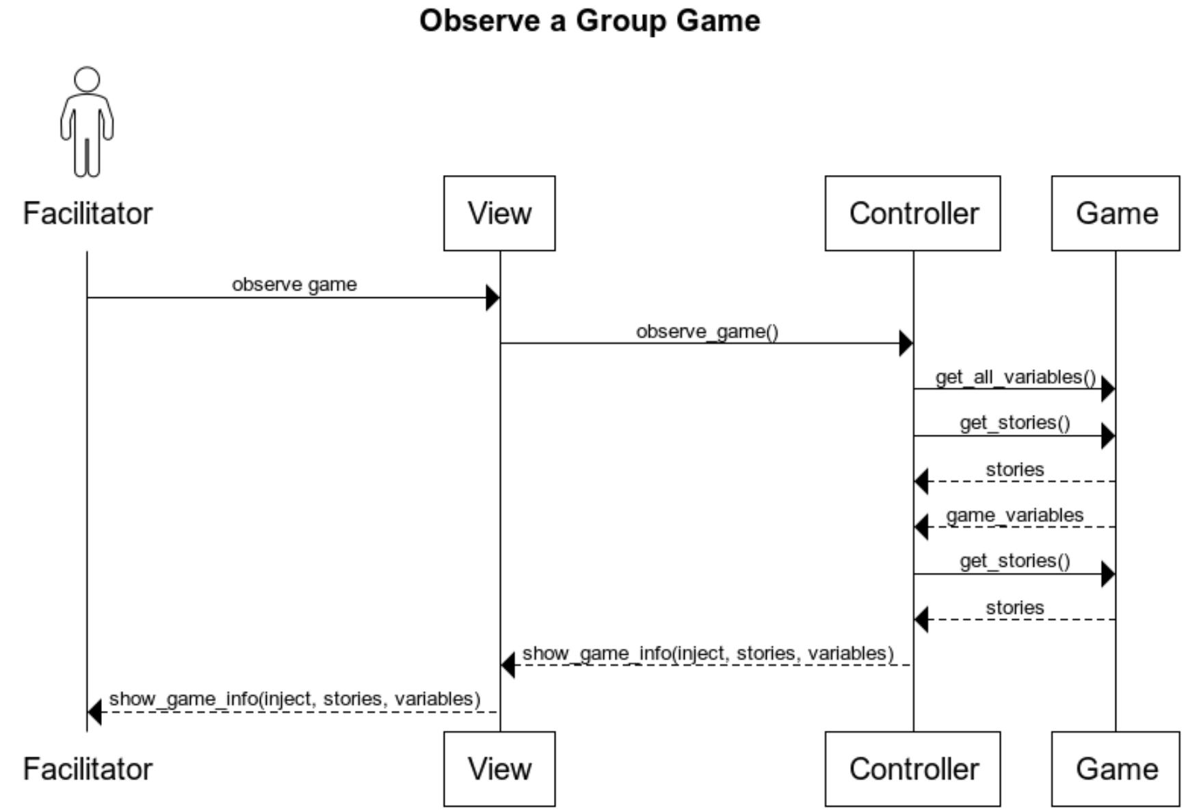

Figure 4: Observe a Group Game

### Facilitate a Group Game

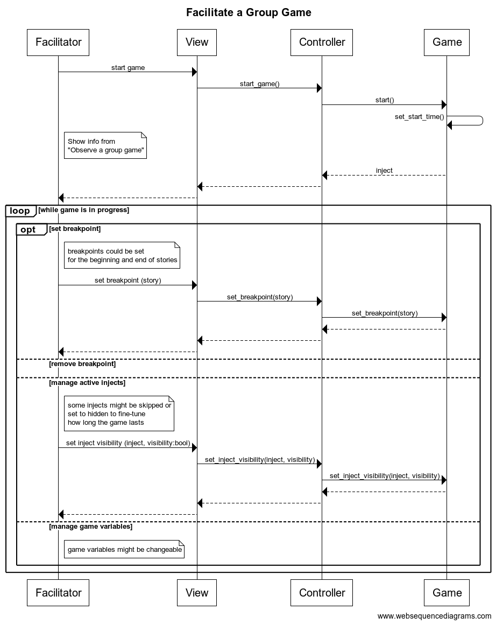

Figure 5: Observe a Group Game